Topic: Advanced Practice Provider (APP) Student Sends Note to Preceptor for Endorsement  Facility: IU Health Facilities  Audience: APP Students and Preceptors |  | Effective Date  TBD  Contact  IU Health Help Desk  helpdesk@iuhealth.org
Overview: | This document provides a brief outline for the Advanced Practice Provider (APP) Student to preceptor note workflow. This workflow provides appropriate regulatory compliance to support the preceptor to sign notes written by APP Students.
APP Student Workflow – Submit a Note to a Preceptor
Step | Action
Click the Sign/Submit button.
Students are required to choose a preceptor for verifying signature.
Select a preceptor to submit the note to for endorsement.
- In Dynamic Documentation (Dyn Doc):
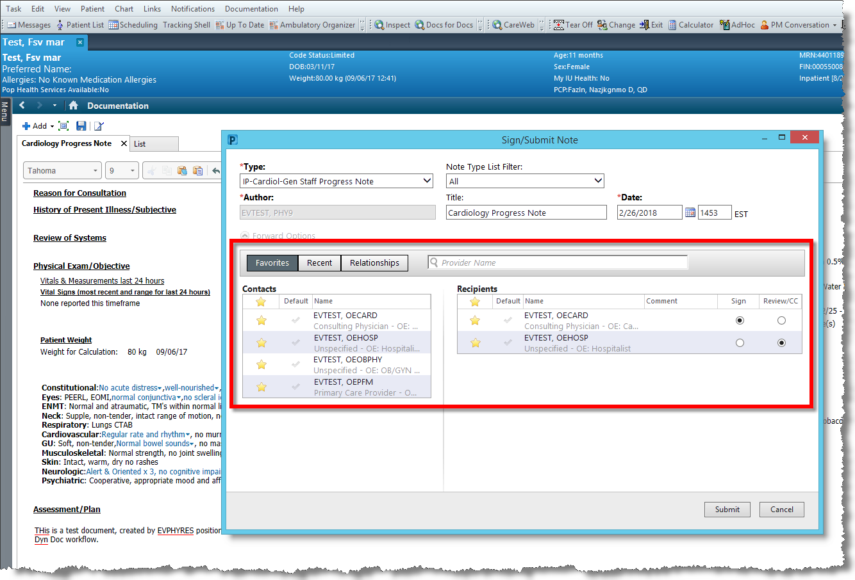
Continued on next page

APP Student Workflow – Submit a Note to a Preceptor (continued)
Step | Action
(continued) | - In PowerNote:  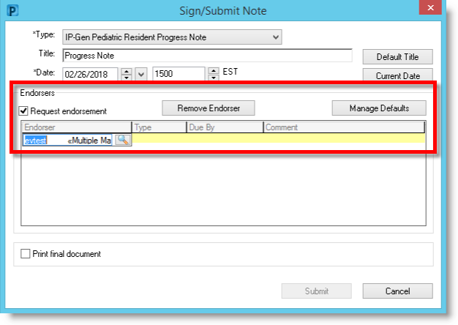
Click the Submit button (there is no Sign button).
When submitted by the APP Student, the note is placed in an (Unauth) – ”Unauthenticated” – status, remains visible to other users in Workflow and displays a “Preliminary Report” heading when opened.
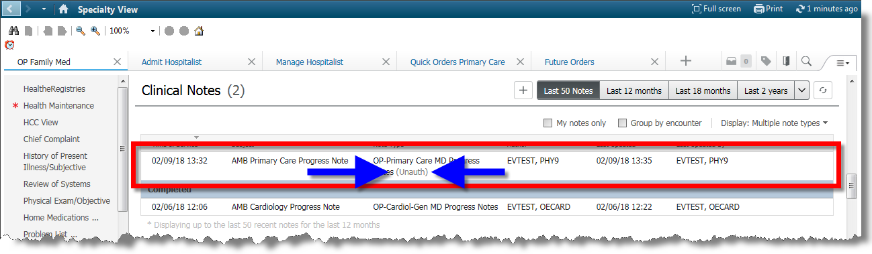
Note Statuses Meanings
“In progress” – Author is still writing note.
“Unauthorized” – App Student has submitted note to preceptor.
“Completed” – Authentication signature from preceptor has been completed.

Continued on next page

Preceptor Workflow – Make Changes and/or Corrections to a PowerNote
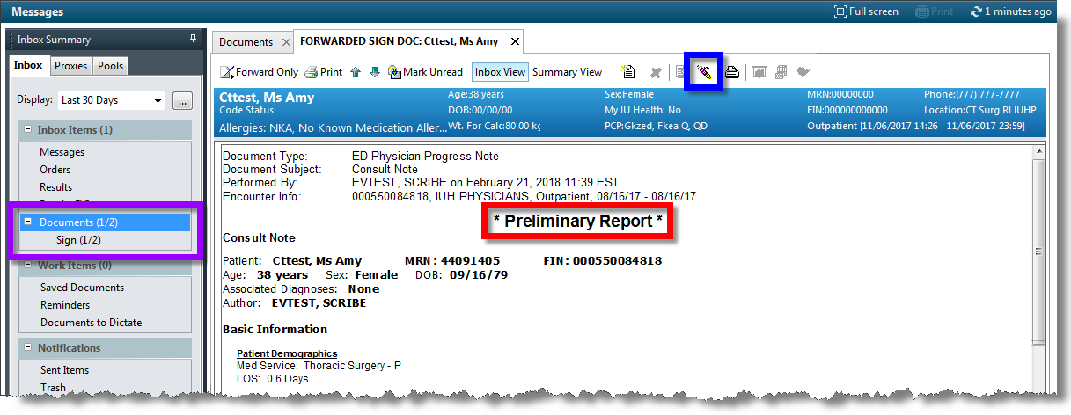
- When opened, the note header reads, “* Preliminary Report *.”
- The preceptor receives the submitted note in Message Center, as in the past, in the Sign folder.
- The preceptor can now make direct changes/corrections to the note before signing.
Important Notes:
• If the preceptor wants to addend (NOT edit) the note, they may still do so. They must sign the note and then modify with an attestation statement. The attestation statement and signature line will separated by a bold line and additional time stamp.
• If the preceptor wants to make edits and also attestation statement, they should follow the workflow below. The attestation statement and signature line will not be separated by a bold line and time stamp.
Continued on next page

Preceptor Workflow – Make Changes and/or Corrections to a PowerNote (continued)
Step | Action
 | Open the note in Message Center (in the Sign folder).
Click the Correction ( ) button on the toolbar.
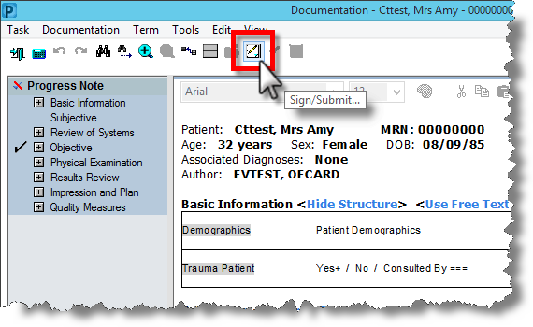
The PowerNote re-loads for corrections.
 | Make any changes or corrections, as needed.
Click the Sign/Submitbutton.

The following screen shot illustrates how the note displays after it’s been verified.
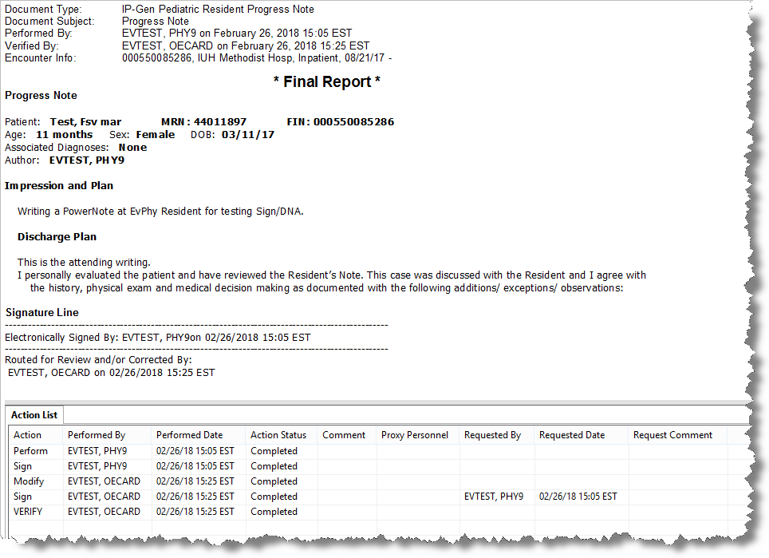
Continued on next page
Preceptor Workflow – Make Changes and/or Corrections to a Dyn Doc
Step | Action
 | Open the note in Message Center (in the Sign folder).
 | Click the Modify ( ) button on the toolbar.
Take action, with these three options.
- Edit the document.
- Add new content to the document.
- Skip to Step 4 (Sign only).
Sign the document.
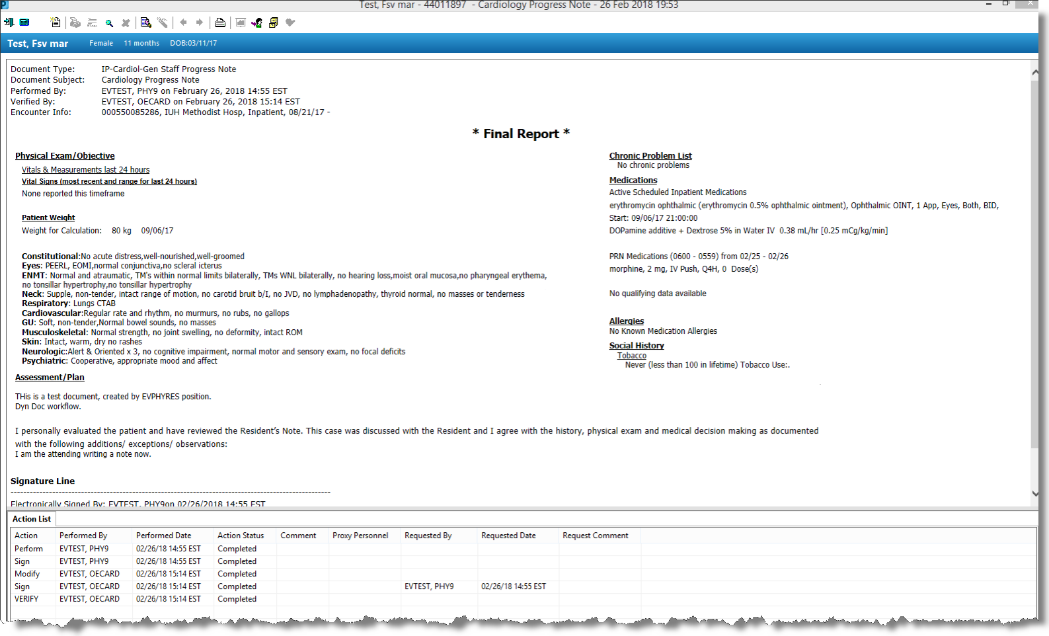

Continued on next page

Preceptor Workflow – Add an Addendum to a PowerNote
If the preceptor wants to addend (NOT edit) the note, they may still do so. They must sign the note and then modify with an attestation statement: the attestation statement and signature line will be separated by a bold line and additional time stamp.
Step | Action
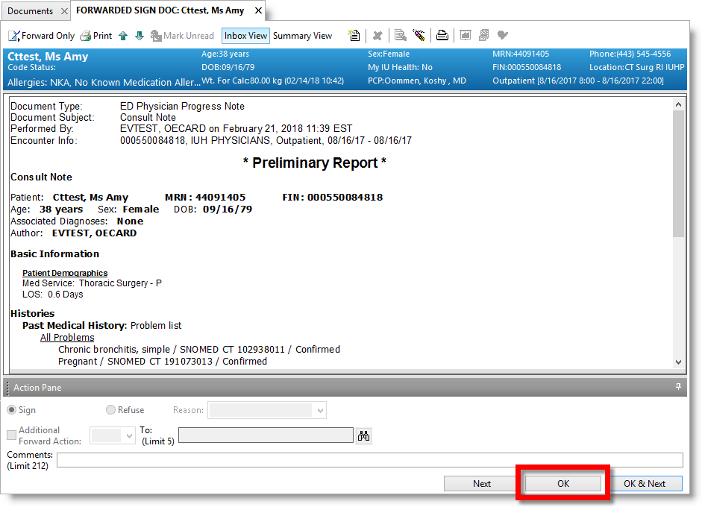
Open the note in Message Center (in the Sign folder).

Click the OK button.
This signs the note without any edits, and places it in a final, verified status. The note will now display in a “Final Report” status.
Click the Modify ( ) button on the toolbar.
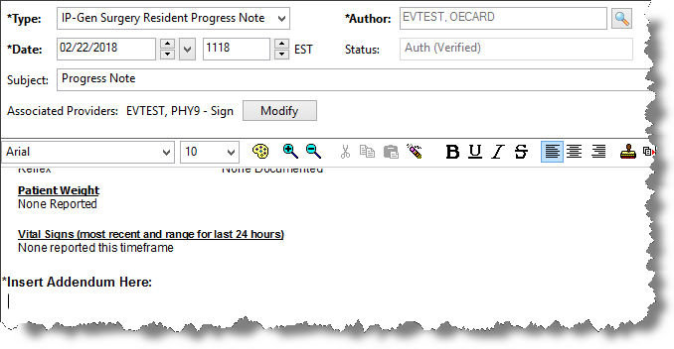

The note opens and the cursor is positioned below the “Insert Addendum Here” heading.
Continued on next page
Preceptor Workflow – Add an Addendum to a PowerNote (continued)
Step | Action
Enter an addendum.
All attestation statements are still present.
Click the Sign button.
The signed note remains in a “Final Report” status.
Note: The App Student remains the Author of the Note, and student and preceptor signatures are both present in the Signature Lines.
